Part A q1

Part A q2

Part B q1

Part B q2

Part C q1

Part C q2

Part C q3

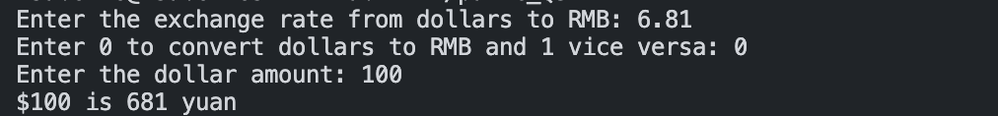

Part C q5

Part C q6

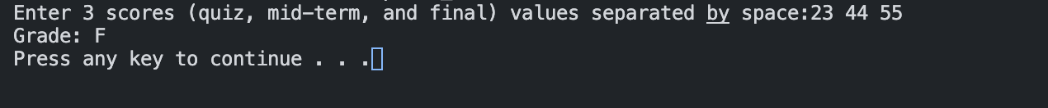

Part C q7

Part C q8

